**QualitySoft: UseCases for Contact List Project**

**Use Case 1a**: Enter a new person into the contact list

**Actors**: user

**Preconditions**: The user has chosen to enter a new person into the contact list

**Primary course**: The user enters first name, last name, street address, email address, phone number and notes.

**Alternate courses**:

1) If the user leaves one or more of the fields blank, the person will still be entered into the contact list.

2) If the user cancels out of the operation in the middle, the person will not be entered into the contact list.

**Exception courses**:

1) If the user leaves the last name and/or the first name blank, then the person will not be entered into the contact list.

2) If the user enters an email address that does not satisfy the correct syntax for an email address, the system asks the user to reenter.

3) If the user enters a phone number that does not satisfy the correct syntax for a phone number, the system asks the user to reenter.

**Postconditions**: The new person is stored in the contact list in memory.

When you run the Main() inside of the HomePageController class, you are greeted with the Home Page as seen below.

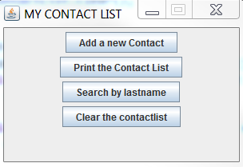

When you click the “Add a New Contact” button, you are taken to the window that looks like the one seen below

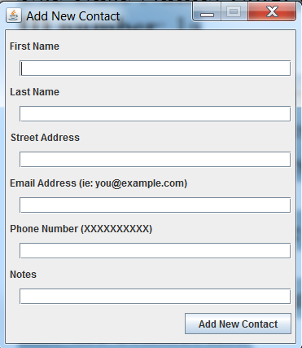

From here, you can load the information for your contact in to the Add New Contact form

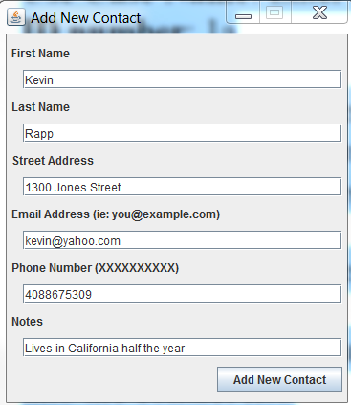

And when you press the “Add New Contact” Button seen above, the program will create a new Person object, add it to the Contact List and give you the below message dialog

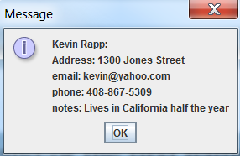

In order to check that the contact was added, we can use the Print the Contact List method on the Home Page.



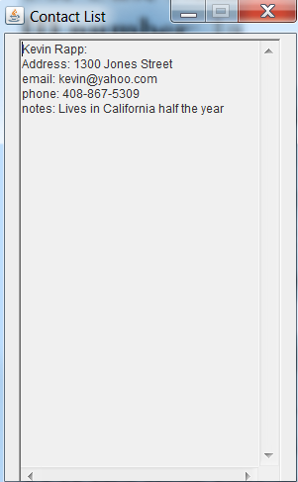

In the event where you attempt to add a contact with no last name:

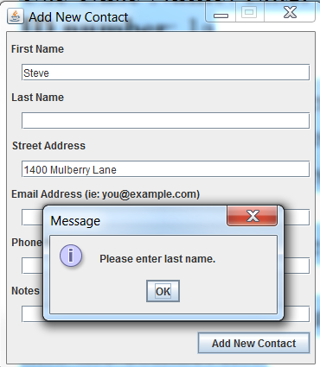

In the event where you attempt to add a contact with no first name:

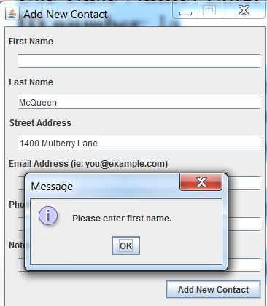

In the event where you attempt to add a contact with an incorrect email format:

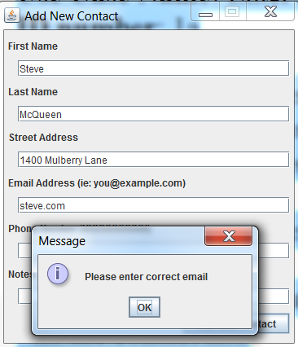

In the event where you attempt to add a contact with an incorrect phone number format:

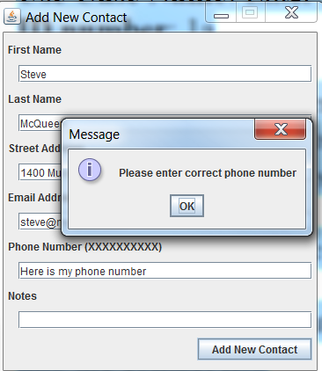

**Use Case 2**: Print the contact list

**Actors**: user

**Preconditions**: The user has chosen to print the entire contact list

**Primary course**: The system prints all information about all contacts to the console, sorted by last name.

**Alternate courses**: none

**Exception courses**: none

**Postconditions**: The contact list is printed to the console, sorted by name. If there are two contacts with matching last names, these two contacts will be ordered by first name.

On top of the two Person objects added in the top (Kevin Rapp and Steve McQueen), I have added three additional Person objects (Larry Rapp, Stanley Yelnats, Bruce Wayne) for proof of this case.

We make our way back to the home screen and press the “Print the Contact List” button



And are left with the following output:

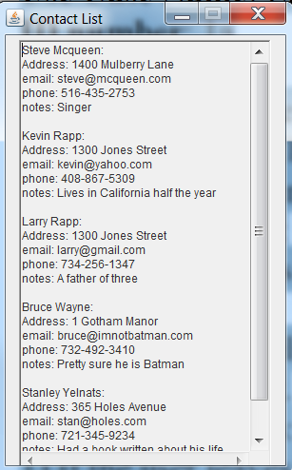

**Use Case 3**: Retrieve a person's information by last name

**Actors**: user

**Preconditions**: The user has chosen to retrieve a person's information from the contact list by last name

**Primary course**: The user enters a last name, and the system displays all of the information that was previously entered on that person.

**Alternate courses**:

1) If there is no one in the contact list with the given last name, the system will display a message to the user telling her that.

2) If there is more than one person in the contact list with the given last name, then all of the people with that last name will be displayed.

**Exception courses**: none

**Postconditions**: All contacts with the given last name are displayed.



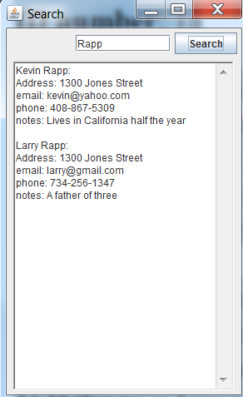

In the event where you attempt to Search for a last name that is not in the contact list:

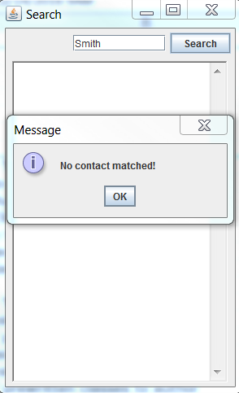

**Use Case 4**: Quit the program and save to disk

**Actors**: user

**Preconditions**: The user has chosen to quit the contact list program.

**Primary course**: The system saves the current contact list to disk and exits gracefully.

**Alternate courses**: none

**Exception courses**: none

**Postconditions**: There is a data file on the disk containing all of the current contact information.

Saves a file in the WorkSpace called “data” that contains the information entered in. Recheck that it works by reprinting the contact list:

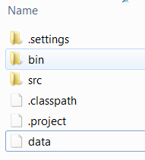 

Picture of the file “data” saved to disk

**Use Case 5**: Start the program and open the existing data file on disk

**Actors**: user

**Preconditions**: The user has chosen to start the contact list program.

**Primary course**: The system finds the current contact list file on disk, opens it and reads it into the list in memory.

**Alternate courses**: If there is no contact list data file on disk, then the system begins with an empty contact list.

**Exception courses**: none

**Postconditions**: There is a contact list in memory containing any contacts that were entered previously.

